APEO PROJECTS AND PROGRAMS FROM 2006-2013

The Association for Promotion of Equal Opportunities, in its desire to create the preconditions for faster and more complete socialization, as well as the highest possible level of independent living for persons with disabilities (PWD), strives to identify the needs and priorities for creating equal rights under conditions of equal opportunity for persons with disability. As the member of civil society APEO strives to find practical ways to resolve the problems of persons with disability. With that in mind, it tracks social realities and the specific problems of persons with disability in order to use expert knowledge and methods, or at least to draw attention to the need for change through positive examples in practice.
The fact is that to satisfy quality social needs for persons with disability, it is necessary to absolutely understand actual changes of the process happening in our society. These changes are first of all in relation with recent very actual process of decentralization in Croatia. Local communities have more responsibility and they have to create activities with which to significantly improve quality of life for persons with disability, and thus make it possible for their total fulfillment of their basic human rights. Furthermore, there is a need for connecting and sharing activities of all stakeholders in communities (local government, counties human right offices, centers for social welfare, associations for persons with disability, relevant institutions and organizations, business subjects and civil society) to overcome many obstacles in relation with quality achievement of basic human rights for persons with disability. However, there are many difficulties. For instance, there is a problem in implementation of legislative regulations (280 legal acts that regulate the life of persons with disability in Croatia).
Concretely: regulation for removing obstacles for accessibility is wonderful, but is not being implemented; there is a right for providing free of charge transportation for persons with disability, but it is not in force; it is guaranteed to give a needed nurture and help at home, depending on individual needs, but it is almost impossible due to lack of services for implementation; it is guaranteed dignity to persons with disability, but in practice it stumbles with first step when due to lack of money person with disability and tied to wheelchair does not have adapted bathroom and is not able to maintain basic hygienic needs. And etc.
With reference to the above the task of everybody who can contribute and directly act in solving a specific needs of persons with disability but also influence on the culture of life and education of stakeholders on all levels, starting from institutions to citizens, to do as much as possible with their involvement for dignity and better life of persons with disability.
And this task APEO placed in its priority of activities.
APEO, as the member of the Croatia Union of Physically Disabled persons (CUPDPA) and one of the founders of Human Rights House Zagreb, participates in all of their activities which improve the culture of life, fight for human rights and the quality of life to vulnerable citizens - persons with disability.
During the five-year existence of UPIM and implementation of projects in the area of empowering unemployed PWD, it became evident that one of the significant problems was in fact the issue – employment. If a PWD has not found a job within one year of completing their education, they become passive, and they begin to lose the knowledge they gained during their education; they also begin to lose their will to work and become an active member of society. In addition, the position of PWD in the labor market is circumscribed by poor positioning in an educational system that is not attuned to the needs of the labor market, which means that efforts must begin with education. For that reason, UPIM has implemented several projects aimed at educating PWD.
In promoting the offering of organized expert help in empowering PWD for employment, support in adapting to the new working environment is crucial, as is the support offered to employers in organizing the work process and securing suitable working conditions for PWD. It is also essential to familiarize employers with the possibilities, capabilities, and specific characteristics of PWD through incentives during the employment period as well as promoting employer sensitivity and using examples of good practices. So that this may be achieved in an optimal way, the persons with disabilities themselves must know their rights and be prepared to provide that information.

With reference to the above mentioned goals we present a list of APEO projects completed and in progress as the precursor of all envisioned future projects:
- 2006. project: Encouragement workshops for unemployed persons with disability
“HOPE DIES LAST”
Donator: Ministry of health and Social Services
Location: Zagreb

- 2007. project: Continuation of encouragement workshops for unemployed persons with
Disability
Donator: Ministry of Health and Social Services
Location: Zagreb
RESULTS:
- Giving importance to the problems of employment of young persons with disability in four cities: Bjelovar, Split, Zagreb and Slavonski Brod;
- Confirming the facts about real difficult situation in employment of persons with disability.
- Assembling experts dealing with concrete problems in Croatia and forming expert team and collaborators working on the same issues but from different levels of responsibility;
- Opened new possibilities of correlation, exchange of experiences but stronger bonding and joint activities;
- Enabled mutual acquaintances and exchange of experience trough direct contact and thus enriching experiences of experts and persons with disability; and all of this enhance better implementation of legal acts, existing national strategies, programs and measures in Croatia;
- Strengthen persons with disability by their partaking on workshops and attain new courage presenting themselves in front of potential employers and to be able to actively participate in society;
- Introducing persons with disability with possibilities of individual solutions in their places of living;
- Increased level of knowledge and information of unemployed young persons with disability;
- Open ways of faster changes of policies and behaviour of targeted local levels but also on the level of entire society in relation to persons with disability employment;
- To make public via media about problems and needs of young unemployed persons with disability and about possible improvements of existing situation;
- To encourage work of volunteers on the local level;
- To create conditions for stronger participation in creation of further suggestions of measures and activities- based on real needs and concrete cases in targeted local communities where workshop were held;
- Concrete life knowledge that makes possible noting down and formulating suggestions with which will it would be possible to supplement the work of government institutions.

- 2007.project: TO GET A JOB IS POSSIBLE
Donator: City of Zagreb –City office for education, culture and sport
Location: Zagreb
RESULTS: Beneficiary of these workshops in the Centre for development and education were:
- Informed about labour market demands and employees expectations;
- Becoming aware of their own positive personalities, skills and capabilities necessary for active participation in the open labour market;
- Developed positive attitude about possibilities of employing persons with disabilities on the open labour market;
- Motivated for active search of employment and achieving social integration;
- Educated about the way how to present themselves to employers trough well prepared CV and excellently prepared application;
- Informed about measures and benefits for employers if they employ person with disability
- Informed about rights of persons with disability, measures to implement them and about protection;
- Informed about additional educations that are momentarily available and that could be useful when job searching;

- 2008 project: With information to easier employment for persons with disability
Donator: World Bank
Partner: Croatian National Institute of Public Health, Zagreb
Location: Zagreb
RESULTS: All mentioned parameters about persons with disability employment will be in the form of expert work, during May 2009, published in Croatian magazine of public health, while during January 2009 will be implemented in II Report about the persons with disability published by Croatian Institute of Public Health on their web page www.hzjz.hr and web page of Association for Promoting Equal Opportunities (APEO) www.upim.hr . Here is needed to emphasise that the parameters about employment received based on support from the World Bank , will be used as significant foundation for showing the position in employment persons with disability in Croatia while preparing various action plans, strategies or government policies and to include to PHD titled: Influence of employment on the life quality of women with disability. All above mentioned forms will be available to wider public and this scientific-expert approach promoting the importance of employment will enable better implementation of National Strategy for equal opportunities for persons with disability. From all the above it is evident that the results of the project for promoting quality of life and creating equal opportunities for the persons with disability it is not possible to measure only once and to present but its importance of the project will ,multiply in the future. Based on this it is underlined that the World Bank will be getting regular reports about all advancements that came out of the World Bank support. The first next report will be in September 2009 when the previously mentioned work will be presented, as well as bulletin and PHD paper.

- 2008. Project: 10 STEPS to the individual support for employment
Location: Zagreb, Međimurska County
Donator: Ministry of Health and Social Services
Partners: Međimurska County and Centre for Social Services Čakovec

RESULTS: All candidates had experienced obvious increase of self-confidence and they learned to write CV’s, applications and they accepted a wide spectre of advices about how to behave on interviews for jobs
Trough the work of Expert Committee was defined a model of individual support to employment of persons with disability based on principals of reciprocated cooperation of civil, public and business sectors.
Nine persons from Associations and other supporting institutions trained to give individual support in employment of persons with disability will participate in implementation of pilot model;
Eight persons with disability in total will be actively engaged in job-searching and they will receive systematic and continued individual support during job-searching.
Furthermore, on the last workshop following results were established:
- 2 beneficiaries were employed during workshop
- 1 beneficiary finished her education and wrote and entrance exam to University
- 1 beneficiary started to work in family business
- To all beneficiaries it was made possible to use internet, thanks to cooperation that was established with Autonomous Centre Čakovec.
- 2009.project: Establishing factors that influence the quality of life and health of women
with disability at actively working age
Donator: Ministry of Health and Social Services
Partners: Croatian National Institute for Public Health
Location: Croatia

RESULTS: The project is near end and statistics are being prepared
- 2009. project: National Campaign for persons with disability employment-
A CRISES IS CONSTANT FOR US!

Donators: USA Embassy, Swiss Embassy and Croatian Hydrographical Institute
Partners: BBDO, Print GRUPA, Zagreb Plakati, RTL, OTV, local TV stations,
Croatian Employment Agency, Foundation for Professional Rehabilitation and Employment; Croatian Employer’s Association
With the contribution in kind with extensive work of volunteers
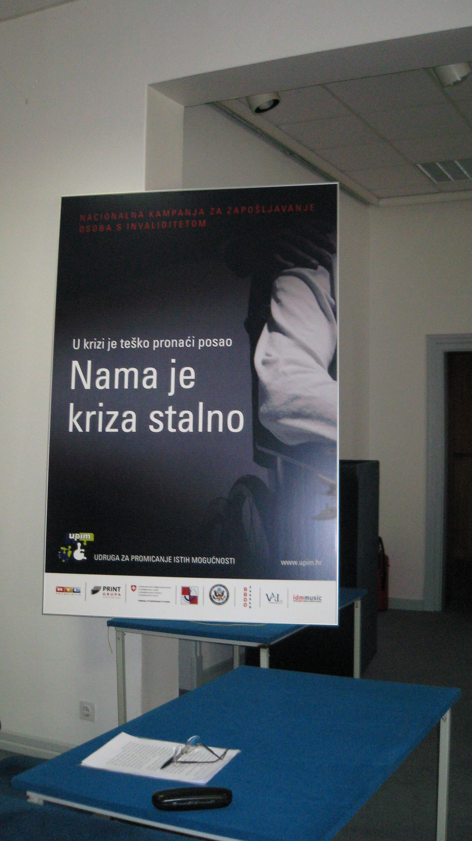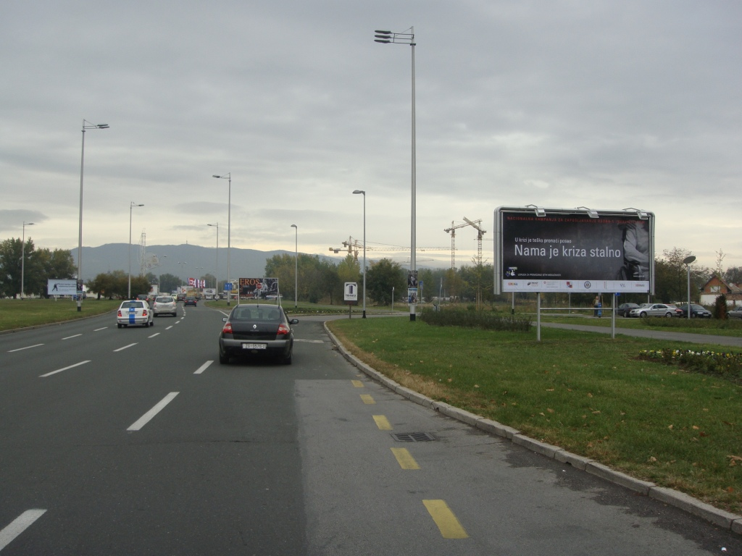

RESULTS: This APEO Campaign has two important aims: with first to influence the change of society conscience and especially employers and with second to send a message to persons with disability than in the struggle for their basic human right-the right to work- they are not alone.
The Campaign is envisioned as one year activity as media promotion for employment of persons with disability and with this in mind it was created a TV spot, radio spot, jumbo poster, city light and banner. Kick off the Campaign was announced on the press conference October 21. 2009.
The main media partner RTL television is broadcasting spot, five to ten times per day and that opened the door to other media. In the first day after the press conference the directors of OTV television started to broadcast the spot. Invitation came from HRT I to participate in one hour program “Normal life”, and after that in OTV show “Svakodnevnica”; then appearance in one hour Kapital Network show- first business television in this region. We are participated in talk show on Catholic Radio on November 9. 2009.; Radio 101 November 10.2009 and subsequently on other local radio stations.
On web pages Styria and Lisa are available short texts with pictures about the Campaign:
http://www.story.hr/nama-je-kriza-stalno-36836
http://www.cro-rss.com/article_8220nama_je_kriza_stalno8221__5100032.htm
http://humanrightshouse.org/Articles/12356.html
The same was published on the Association for Promoting Equal Opportunities APEO (UPIM) web page www.upim.hr.
Donation to the Campaign in the amount of 6.000 calendars was received from PRINT GRUP. 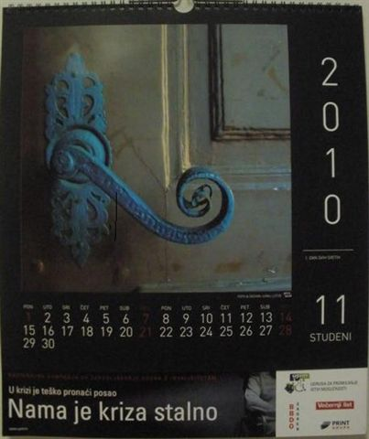 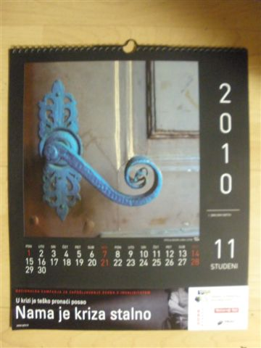
The Cooperation Agreement was signed with the newspaper “Poslovni dnevnik” and the occasional leaflet was sent out to 50.000 addresses.

The extensive support and cooperation in implementation of the Campaign was provided by Croatian Employment Services, Foundation for Professional rehabilitation and Employment and the Croatian Association of Employers.

- 2009.project: THE PART OF CULTURE MISSING IN CROATIA- warning about parking accessibility for persons with disability
Donator: Croatian Lotto
Partners: Ministry of Sea, Transport and Infrastructure,
Ministry of Interior with local police Stations
Location: Zagreb

RESULTS: 350.000 warning leaflets was published for implementation of the Campaign and they were distributed in cities throughout Croatia.
On April 9.2010 a round table will be held dealing with this issue.

- 2009. project: Basic Activities
Donator: The Ministry of Health and Social Services
Location: Zagreb

RESULTS: purchased essential furniture and IT equipment for APEO office

- 2009. project: A BRIDGE from education to employment of persons with disability
Donator: Ministry of Health and Social Services
Partners: Agency for Vocational Education, Centre Dubrava
Ministry of Science, Education and Sport
Foundation for Rehabilitation and Employment
Location: Zagreb

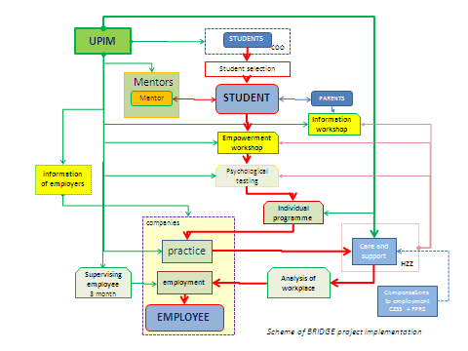

RESULTS: duration of the project is two years – implementation is in process. The action is giving excellent results to the satisfaction of the beneficiaries, their parents and experts including in project.

Projekt 2012:
ETIQUETTE for Better Understanding of Persons with Disabilities
Association for the Promotion of Equal Opportunities (UPIM) from the Human Rights House Zagreb company Ericsson Nikola Tesla - a truly socially responsible company, in mutual partnership together for years they voluntarily collaborate on a series of social activities, and a crown of mutual work is the creation of educational publications for teenageres - Etiquette for a better understanding of people with disabilities. This laudable project evolved from concept to realization is almost two years. In it many hours was incorporated of hard work, enthusiasm and love. It's a investment bet far positive impact on raising awareness especially in the treatment of young people with disabilities.
The implementation of human rights of persons with disabilities and immediate resolution of their difficulties UPIM is strongly committed to promoting tolerance and non-discrimination culture behavior and understanding of diversity.
Following its mission for the benefit of people with disabilities, the same authors were carried away by the idea of changing need in consciousness of society, designed a highly popular book called Little etiquette or how to be a friend with everyone, and in a small pocket book Etiquette in daily communication with the people with disabilities for children of kindergarten age and first graders.
Further targeted actions towards teenage population - is logical sequence of activities so far. The fact that negative attitudes are often a reflection of ignorance and lack of education is incentive for action. Children are growing up and entering the teenage years, influence from parents and school are replaced by influence of the environment that is becoming larger. At that time, their disobedience is characterized as insolence, arrogance and rude behavior.
Nobody is not telling them how it should be and teach them to be different. Even and in the encounter with a person with disabilities, to teach them, help them, direct them how to manage and treat that situations. So they devised educational publications with 68 beautifully designed pages which follow Darko, student of Teachers College, a person with disabilities, in his daily life. That story that Darko conveys to readers is the best gift of all and the best ticket for the EU.
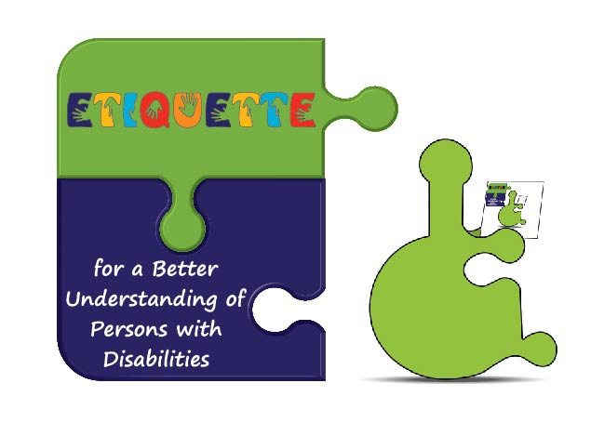
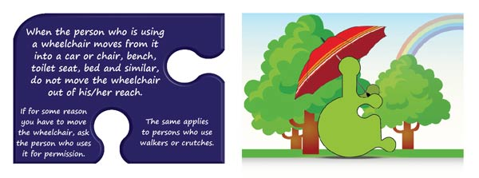
Ministry of science, education and sport is on base of positive reviews of Agency for Education gave approval to UPIM for printing and distribution of publications toward young people. With gratitude to company Ericsson and printing office Kershofset for printing, first copies of this educational publication will be shared as a gift to citizens and in schools, kindergartens, universities - wherever they can influence people on that way to accept people with disabilities as equals, those who enrich our community and which we all should help to live happier. It is planned to publish an edition of 50,000 copies and support is expected from all those who can influence on that. It was translated into English, and soon will be in Italian.
Official promotion of this valuable publication was held at the Museum of Modern Art, 13th December 2012. (on this day six years ago at the United Nations unanimously was adopted the Convention on Rights of Persons with Disabilities - convention in which Croatia was among the first countries signed, had become strong and binding national legislation). Promotion was held at annual Christmas party of company Ericsson on the end of financial year with a call of many Croatian notables. Through this promotion with a short film about the creation of publications, these people have held a speech: company president mr. spec. Gordana Kovacevic, Health Minister dr.sc Rajko Ostojic and president of the Association for the Promotion of Equal Opportunities mr.sc. Mirjana Dobranovic.

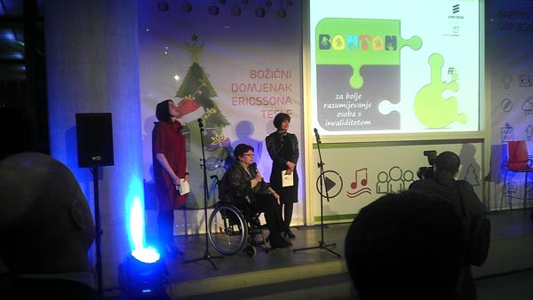

First thousand copies were shared to all guests as a gift at the end of the year. And immediately after that, on invitation of the Coordination for Human Rights of Zagreb County, first teenagers who get first gift of a publication copy were eighth-grade primary school students from four secondary schools in Dugo Selo. UPIM talked with them through an appropriate ppt presentation. Attention and absorption of knowledge were a great value and joy for young people and their teachers, from which UPIM received compliments.

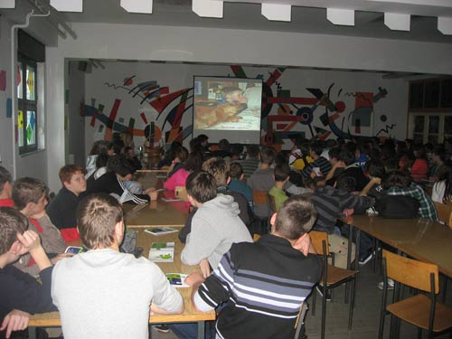

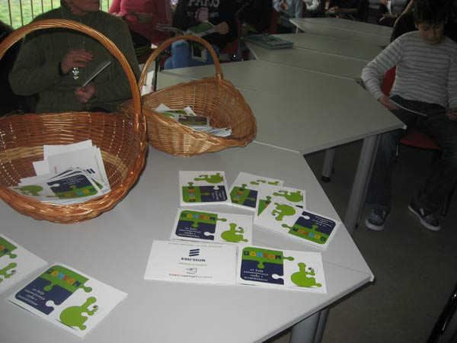

Although is worth pointing out that the entire team that worked on the creation of conceptual publication, has gave up from any fees and that's the best way to show one's own social responsibility and caring for others. In these difficult times, this is a great example of when the little hearts come together - everything is possible!

BITSE International partnership project

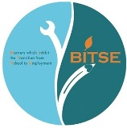

Project Summary
As members of the European Association of Service Providers for Persons with Disabilities, and in association with the many other member organisations, representing both old and new EU member states, this proposed partnership has in depth experience, expertise and knowledge in providing and developing a broad range of services for persons with disabilities. In conformance with the UN Convention on the rights of persons with disabilities and applying in principle, the UN definition of
disability at the coal face of transition to employment programs and services, there is overwhelming evidence as collaborated and specified in the new EU Disability Strategy 2010-2020 (A Renewed Commitment to a Barrier-Free Europe), that persons with disabilities who are in transition from school to employment and work opportunities are either prevented, or at least inhibited from both accessing employment and/or sustaining themselves in the workplace, through interaction with various barriers which in effect hinder their full and effective participation in society on an equal basis with other
citizens (EU Labour Force Survey ad hoc module on employment of disabled people (LFS AHM), 2002). This proposed Partnership, comprised of teachers, trainers, trainees and VET professionals, as well as other social partners and Institutions, and representing the European Union in its broadest context and sense is committed to mutual cooperation on a common theme through an examination of these barriers. It proposes to identify, list and compare barriers which are common or typical to all partner countries, and develop 'common' best practice toolkits and set of recommendations which
will help and support all relevant stake holders in eradicating, diminishing and or overcoming such barriers.
LLP/LDV/PA/2012/IRL-CP601
“Barriers which Inhibit the Transition from School to Employment”
Minutes of the 4th action meeting held in Zagreb, Croatia
on Wednesday 24th and Thursday 25th April 2013
Date: 24/04/2013 – 25/04/2013
Location: University of Zagreb Faculty of Agriculture and Human right house Zagreb and visit program: Center for Training and Education Dubrava and Garden Centar in Baumax East in Zagreb
Host Partner/s: University of Zagreb Faculty of Agriculture and Human right house Zagreb
Apologies: Sonia Staskowiak and Roswitha Müller
Attachments: List of participants/ presentation of the University of Zagreb- project website
Tuesday: 23/04/2013
Arrival of participants to the Westin hotel
Welcome by vice mayor Mrs Jelena Pavičić Vukičević and representiatives of the host partners: Mrs Mirjana Dobranović and prof. dr. sc. Zoran Grgić in Palace Dverce with cultural program: Mrs Ljerka Bjelinski and Mrs Ana Fortuna.
Wednesday April 24th: 10.00 – 13.00
Location: University of Zagreb Faculty of Agriculture
Formal Welcome & Greetings – Michael Barrett, Project Coordination
- Host Organisations CRO
- All Partners/New Participants
Presentation of the University of Zagreb, Mrs Valentina Novak, Office for Students with disabilities of University of Zagreb
Minutes of the last Meeting in Linz: Approval
Overview of Action Meeting Agenda
Item 1: Project Partnership - General Progress Report/update (Michael Barrett)
Work Plans 1-7 (Page 80/81 of Application)
1.- Report on Barriers in every partner country- specified stakeholders (all Partners).
2.- Categorization/Glossary of Barriers (Centre de la Gabrielle)
3.- Develop a ‘Best Practice Tool Kit’ in relation to overcoming barriers (FAZ)
4.- Develop a ‘Best Practice Tool Kit’ of how to examine barriers (UPIM)
5.- Partnership Recommendations (ICR/Dun Manwel Attard YAERC)
6.- Valorisation/Dissemination (EASPD/all partners)
7.- Partnership Quality Assurance Evaluation (MIDDIN/all partners)
Notes/Comments:
- Generally sufficient progress
- Importance of project valorisation programme and dissemination
- Gather the results which are common to all partners
Item 2: Work Plans 1 & 2 Specific Review
Work Plan 1 - Report on “Barriers which Inhibit the Transition from School to Employment”:
General Presentation of overall/final results of the “Trainer/Teacher” focus groups – Teacher/Trainer Focus Group Results: Barriers which are common to all (BITSE) Partner countries given by Sylvia Schanner (BBRZ)
General Presentation of overall/final results of the “Student/Learner” focus groups – Results Learners Barriers Which Inhibit the Transfer from School to Employment given by Eva-Maria Pöltl (Caritas Linz) and Johannes Ungar (Innovia)
Notes/Comments:
Further attention to data presented is required in the context of charts/graphs etc, in order to provide accurate representation of results across partner countries.
Work Plan 2 – Categorisation of Barriers Template
“Barriers which Inhibit the Transition from School to Employment”
Results from all stakeholders: Format/Design & Discussion – Ozlem Saylam, Centre de la Gabrielle –
Notes/Comments:
should be prepared for the 5th meeting in Varna
Number of categorization – improved format
X1 Categorisation template for each Stakeholder of common barriers
X1 Final Categorisation Template for barriers common to all partner countries
Thursday April 25th: 13.30 – 17.30
Location: Human right house Zagreb
Item 3: 5th BITSE action Meeting preview/ Work Plans 3, 4 & 5 ‘Preview’
‘Draft’ documents – Structure & Discussion
Varna, Bulgaria: 3rd–6th June 2013, Host Partners: NASO/NFEDP (Bulgaria)
Draft Schedule & Agenda for the Varna Event/s (NASO/NFEDP)
5th meeting in Varna will be organized in the frame of the Bulgarian national forum 3rd-6th June.
For the organiser 3 topics are important: BITSE work, practices in BITSE project and practice in different countries. For this meeting each of the BITSE partners have to prepare the presentation about the organisation, best examples related to education and employment.
Discussion about draft schedule and agenda
3rd of June – arrival and registration
4rd of June 9.30-12.00 closed meeting of BITSE project
14.00-14.30 joint workshops with BITSE partners and with the Forum participants
5th June: National Forum- 6 speakers – morning session and 9 speakers – afternoon session
Translation simultaneously
General information – package - Georgi Georgiev (NASO)
Important deadlines: till 5th of May – registration of the BITSE participants (the names and the travel details of all participants (mean of transport, place, date and hour of arrival and departure)
Deadline for the presentations and data related to the names of the speaking person, his/her position and if it's possible as well as photo - early in May 2013 due to translation on Bulgarian language.
Discussion in Varna - Best practice tool kits – draft 1 page document – simple – follow the EU examples (Croatia for 3 and 4)
Greece and Malta- recommendation – draft of 1 page (question: what should be about?)
Employer Focus Group Questionnaire – Initial Results & Discussion (NFEDP) introduced by Vera Veleva
It is temporary results from 23 interviewed employers from 5 countries and open to update
Aptitude - attitude
Service Provider Focus Group Questionnaire – Initial Results & Discussion (NASO) introduced by Janeta Filimonova
Discussion about the terminology: provider – trainer - teacher
Provider - Trainer – difference trainer belong to the service provider but not on opposite side
Teacher – in school
Deadline for all results if 10th of May 2013 except some special circumstances and reasonable grounds
Focus Group Context & Format?
PRESENTATION OF Final results for Employers/Service providers - discussion
PersonaL NETWORK Questionnaire: Finalisation complete
Proposal of Astrid Haccou (Middin (former Steinmetz de Compaan – (NL) optional target groups: family, parents, friends
Discussion: “how parents are barriers for their children?”
6th BITSE meeting in Haag – October 2013 – info will be prepared before Varna meeting
Item 4: Work Plan 7: Project QA Evaluation (Page 87 of Application)
Partnership 3rd Quality Assurance Evaluation Report Astrid Haccou – Middin)
Evaluation of the particular time of the Project
Some of the participant in 3rd meeting in Linz has to send the evaluation form
Michael Barrett - it is important for the Project.
According to the project’ outcomes – very sufficient progress
Total Project rate is 86,39% - to follow the progress – 7% up of every meetings
Best and important remarks are on the left side – no progression if all people are happy...
Item 5: Work Plan 6: Project Valorisation (Page 88 of Application)
BITSE Website report (Johannes Ungar) – Solution: all materials/docs will be have to be sent first to Johannes who will inform Michael Barrett when availabvle on website, who will then inform partners that materials are available for access on website.
Website Redesigned and updated (work in progress) – All Sub Sites
Report on Barriers which Inhibit the Transition from School to Employment
- Stakeholder Focus Group Questionnaires
- Stakeholder Focus Group Results
Logo / Brochure report (Fabrizio Fea) – 2 pages that have to be reduced (all partners – have presented in 4 lines – final version of brochure - the end of May
Item 6: Issue of Certificates of Attendance – (EU Commission Required Criteria)
All participants have received the certificate by required criteria. For those participants who haven’t received the certificate we will send them at the beginning of May.
Friday: 26/04/2013 -
PPartner Departure/Other
Signature: Michael Barrett
Date: 30/04/13

